# IT Helpdesk Portfolio – Case Study Report

Prepared by: Justin Asamoah

This report contains a collection of resolved IT support tickets, demonstrating troubleshooting, documentation, and resolution skills relevant to IT Helpdesk and Administrator roles.

## ****Introduction****

This portfolio has been developed to demonstrate my practical skills in IT support and helpdesk operations.  
It simulates real-world scenarios using a ticketing system (Spiceworks) to log, track, and resolve issues.

Each case study highlights:

* Problem analysis and troubleshooting approach.
* Clear documentation of steps taken.
* Use of evidence (screenshots, logs).
* Final resolution and user outcome.

The tickets included cover a range of issues across hardware, software, networking, and account administration, reflecting the scope of responsibilities in a typical IT Helpdesk role.

# Ticket #3 – Laptop not powering on

## Ticket Summary

• User: John Smith  
• Category: Hardware  
• Priority: High  
• Status: Closed

## Issue Description

User reports device won’t boot. No fan noise, no lights. Tried power button reset with no success.

## Actions Taken

- Verified power adapter and outlet working correctly.

- Performed hard reset (power button 30s).

- No response – issued spare laptop.

- Logged faulty device for repair/replacement.

## Resolution

User operational with replacement device. Faulty laptop sent for repair.

## Outcome

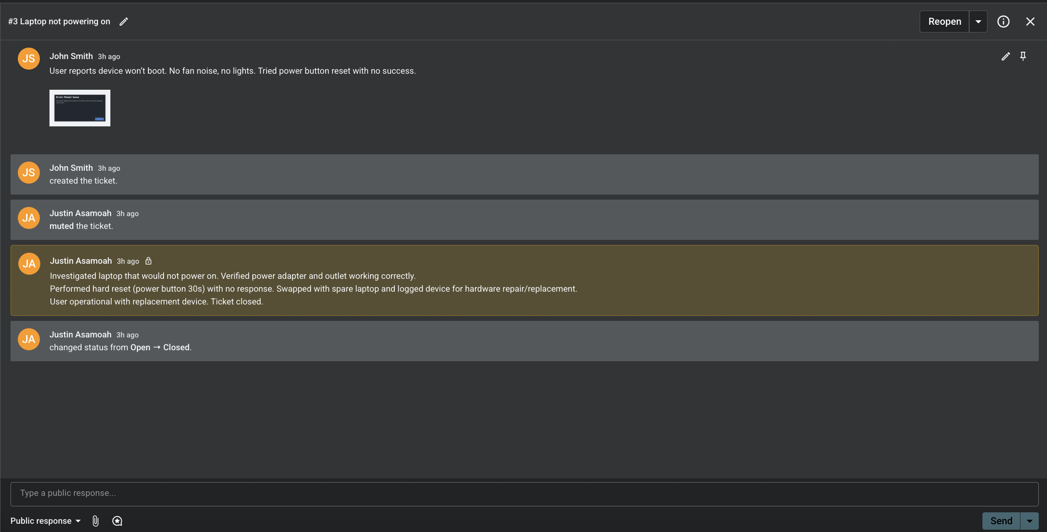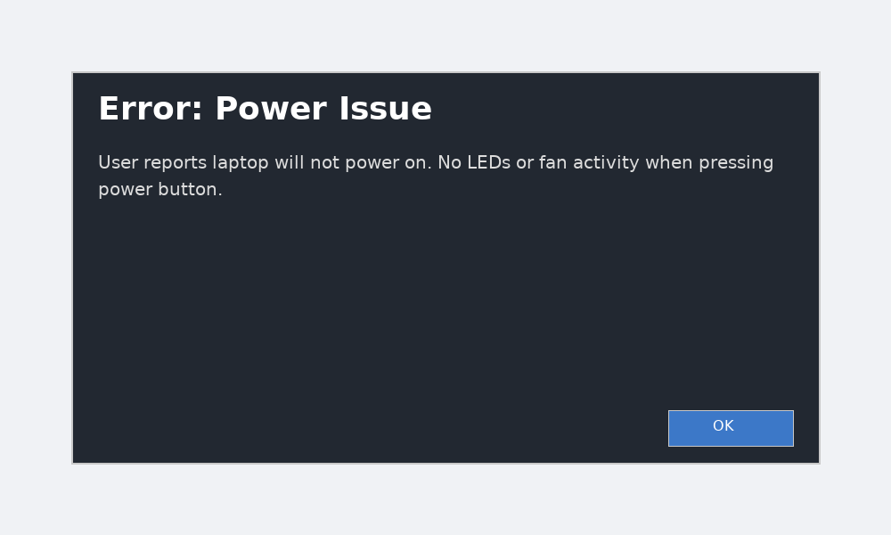Issue resolved. Ticket closed successfully.

# Ticket #4 – Outlook not syncing with O365

## Ticket Summary

• User: Jane Doe  
• Category: O365 / Software  
• Priority: Medium  
• Status: Closed

## Issue Description

User’s Outlook inbox is not updating. Restarted app, but emails only appear in webmail.

## Actions Taken

- Confirmed user could access email via O365 webmail.

- Cleared cached credentials in Windows Credential Manager.

- Recreated Outlook profile.

- Forced manual sync and tested email send/receive.

## Resolution

Outlook desktop client re-synced successfully.

## Outcome

User confirmed issue resolved. Ticket closed.

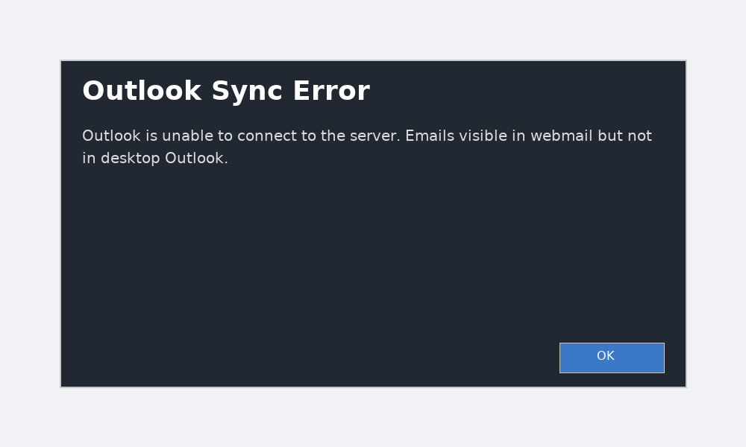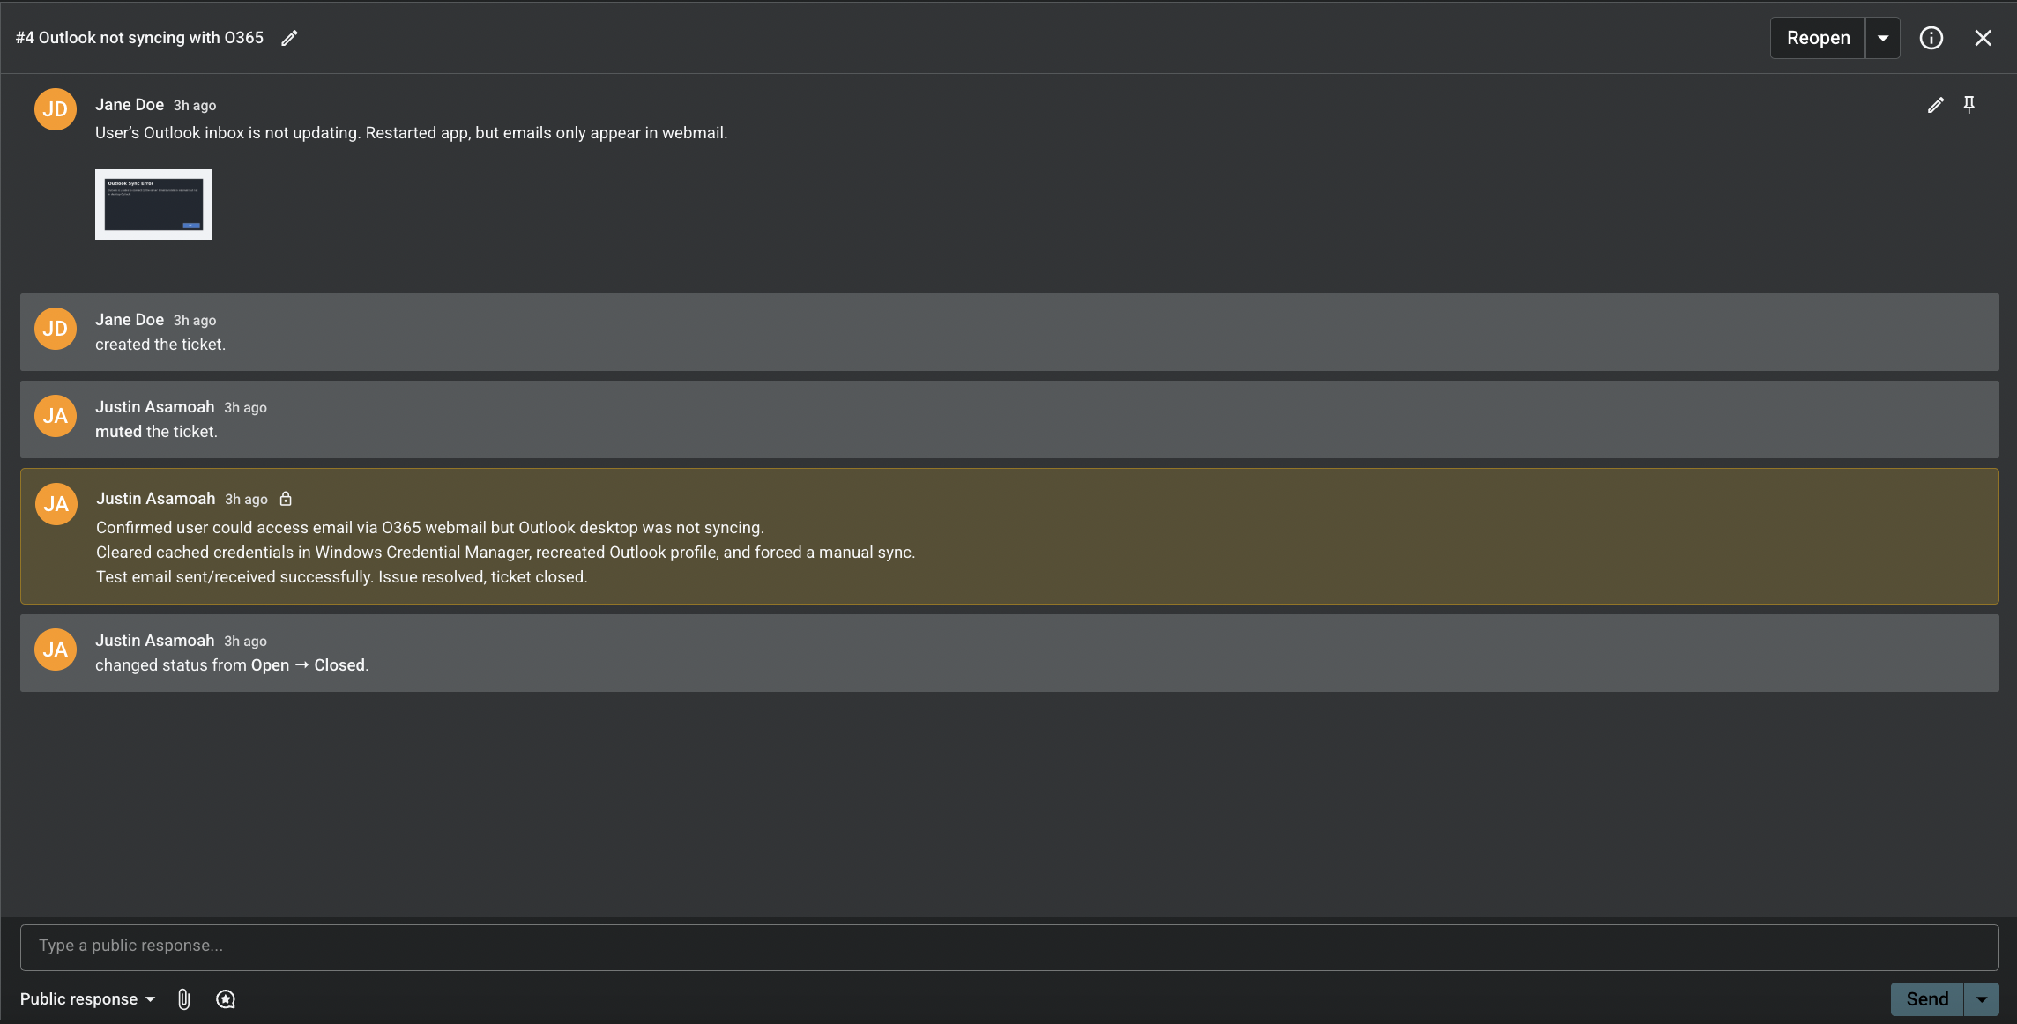

# Ticket #5 – Wi-Fi disconnects every 5 minutes

## Ticket Summary

• User: Michael Lee (Sales)  
• Category: Network  
• Priority: High  
• Status: Closed

## Issue Description

User complains of unstable Wi-Fi connection in meeting room. Drops video calls.

## Actions Taken

- Tested Wi-Fi in meeting room – confirmed intermittent drops.

- Checked router logs for errors.

- Updated wireless adapter driver on affected device.

- Moved user to stable 5GHz band.

## Resolution

Signal stabilised and video call tested successfully without drops.

## Outcome

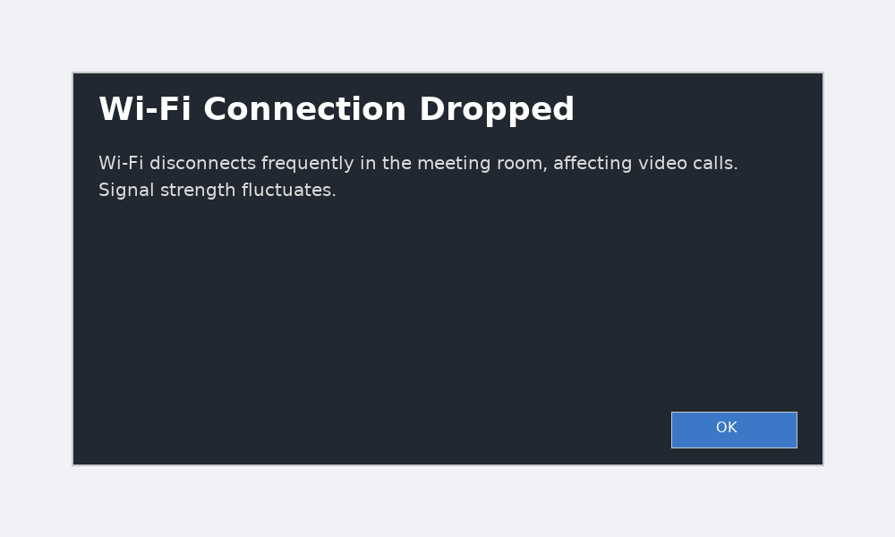Escalated issue to network team for monitoring. User confirmed resolution.

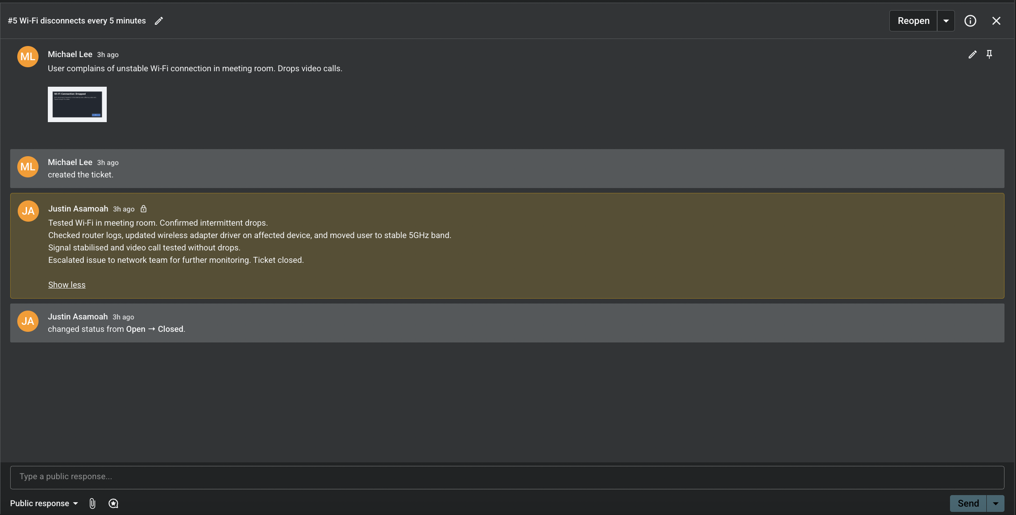

# Ticket #6 – Shared printer unavailable

## Ticket Summary

• User: John Smith (Finance)  
• Category: Hardware  
• Priority: Low  
• Status: Closed

## Issue Description

User unable to print to shared printer. Device showing 'offline.'

## Actions Taken

- Verified printer powered on and connected to network.

- Restarted Print Spooler service on print server.

- Re-added printer to affected system.

- Printed test page successfully.

## Resolution

Printer now available and functional.

## Outcome

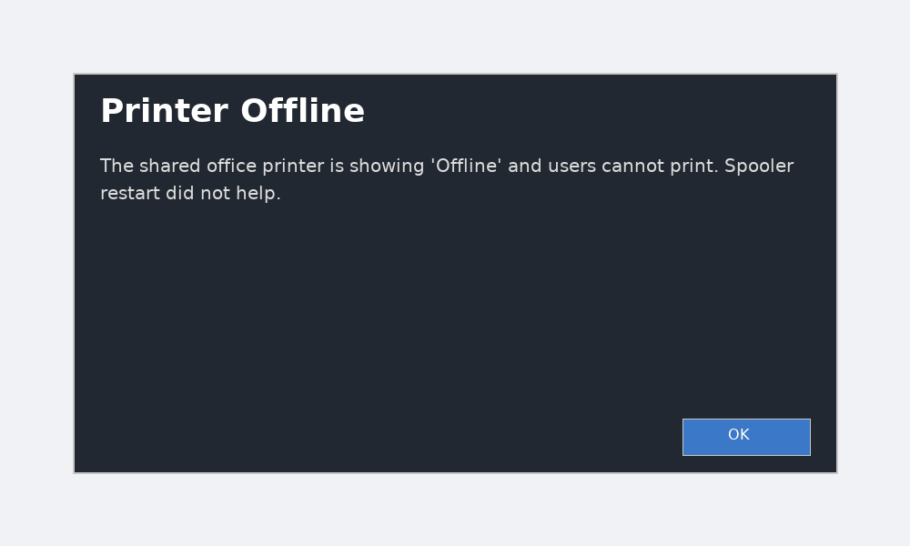Ticket closed successfully.

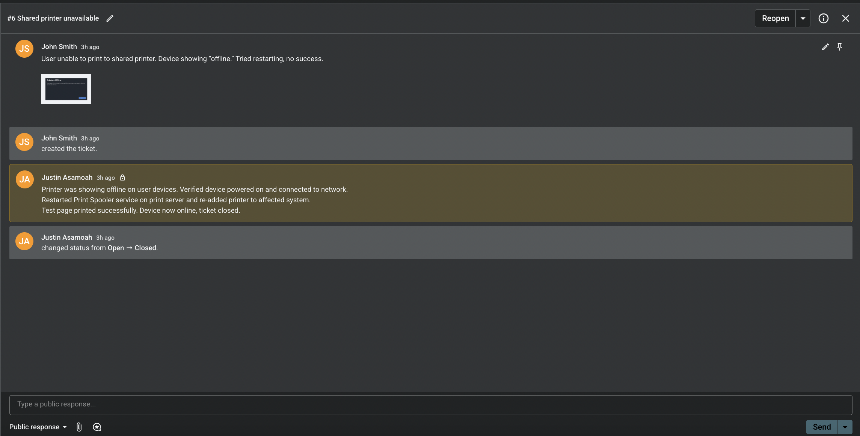

# Ticket #7 – New starter account required

## Ticket Summary

• User: Jane Doe (HR)  
• Category: User Accounts / Admin  
• Priority: Medium  
• Status: Closed

## Issue Description

HR requested account setup for new joiner requiring O365 license, Teams access, and SharePoint permissions.

## Actions Taken

- Created new user account in Microsoft Entra ID.

- Assigned O365 license.

- Configured Teams and SharePoint access.

- Tested login and confirmed mailbox/Teams access.

## Resolution

New starter fully onboarded with required access.

## Outcome

Account documented. Ticket closed successfully.

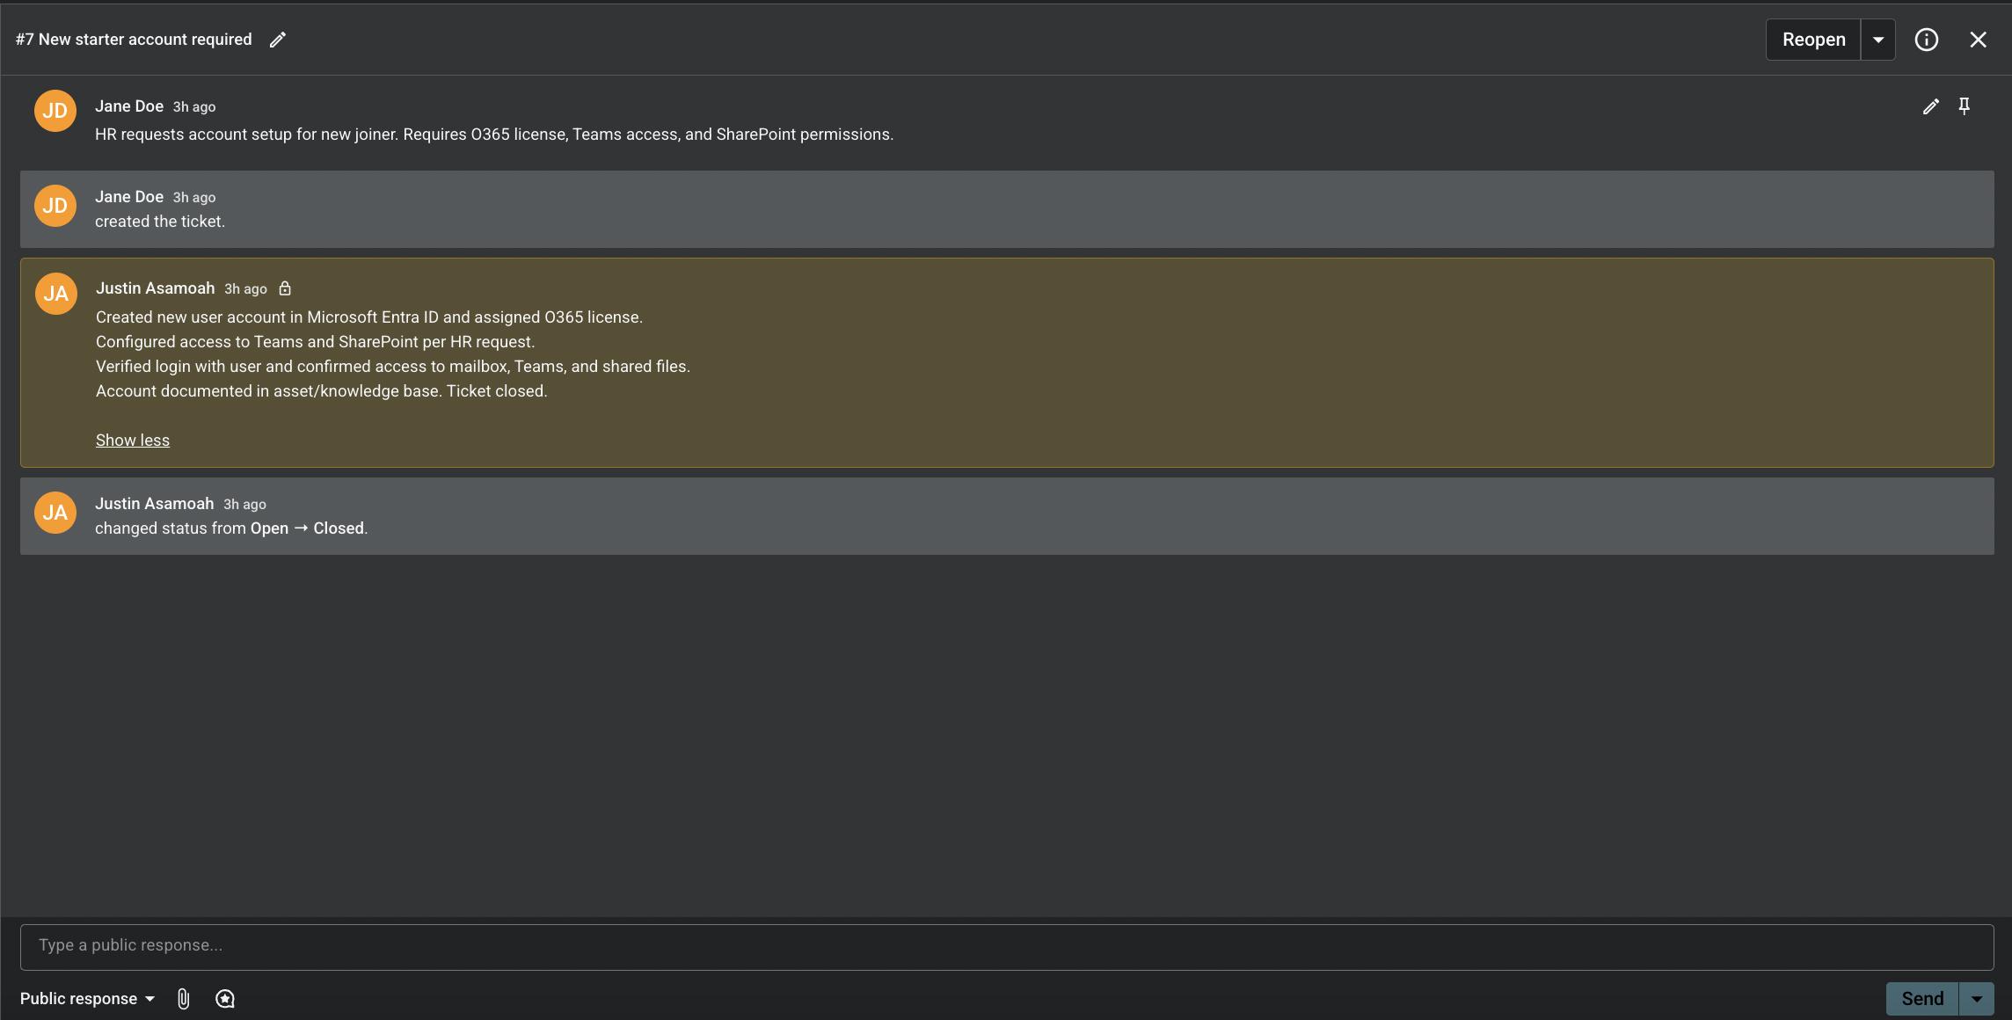

# ****Automation & Canned Responses****

In addition to manual troubleshooting, I implemented **automation rules and canned responses** within Spiceworks to streamline ticket management. This demonstrates not only technical problem-solving, but also my ability to design efficient IT support processes.

* **Automation Rules** were created to categorise and prioritise tickets based on keywords (e.g., “Outlook,” “Password,” “Printer”), reducing manual triage time and ensuring urgent issues are flagged correctly.
* **Canned Responses** were developed for recurring issues, enabling consistent, professional, and rapid communication with users while ensuring all troubleshooting steps are properly documented.

The screenshots included in this section show:

1. The configuration of ticket rules for auto-categorisation and prioritisation.
2. The setup of canned responses for common IT incidents.
3. Example tickets being automatically categorised and resolved using these tools.

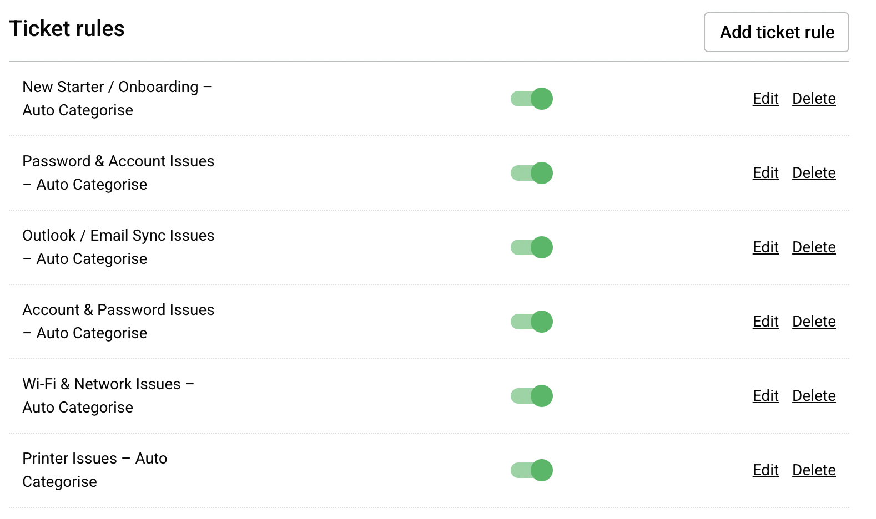This section highlights my ability to combine **technical troubleshooting** with **workflow automation**, skills that are essential for scaling IT support operations and delivering consistent user experiences.

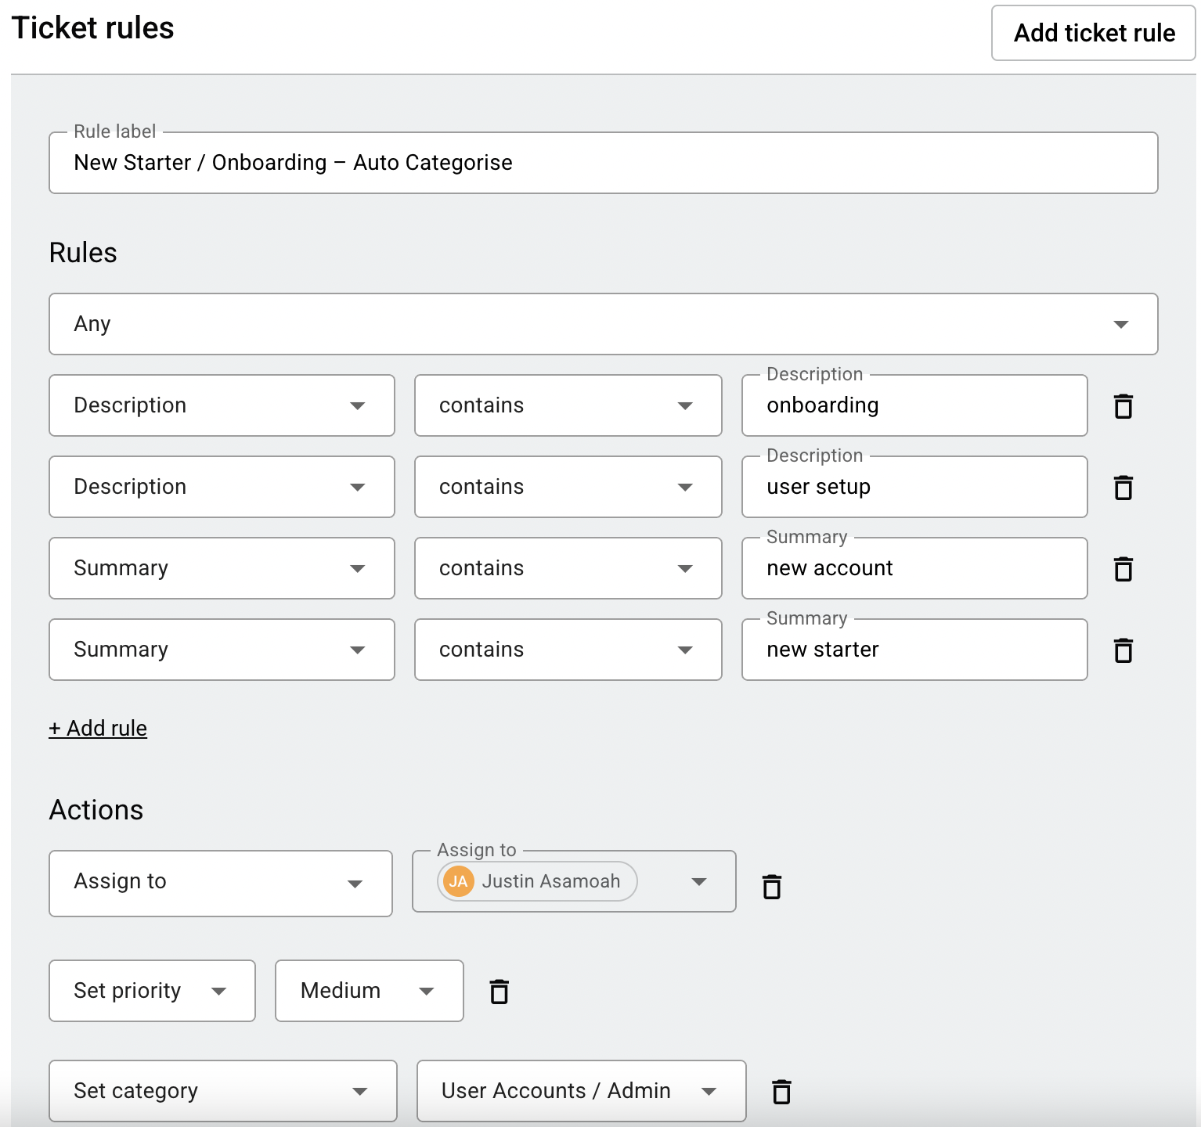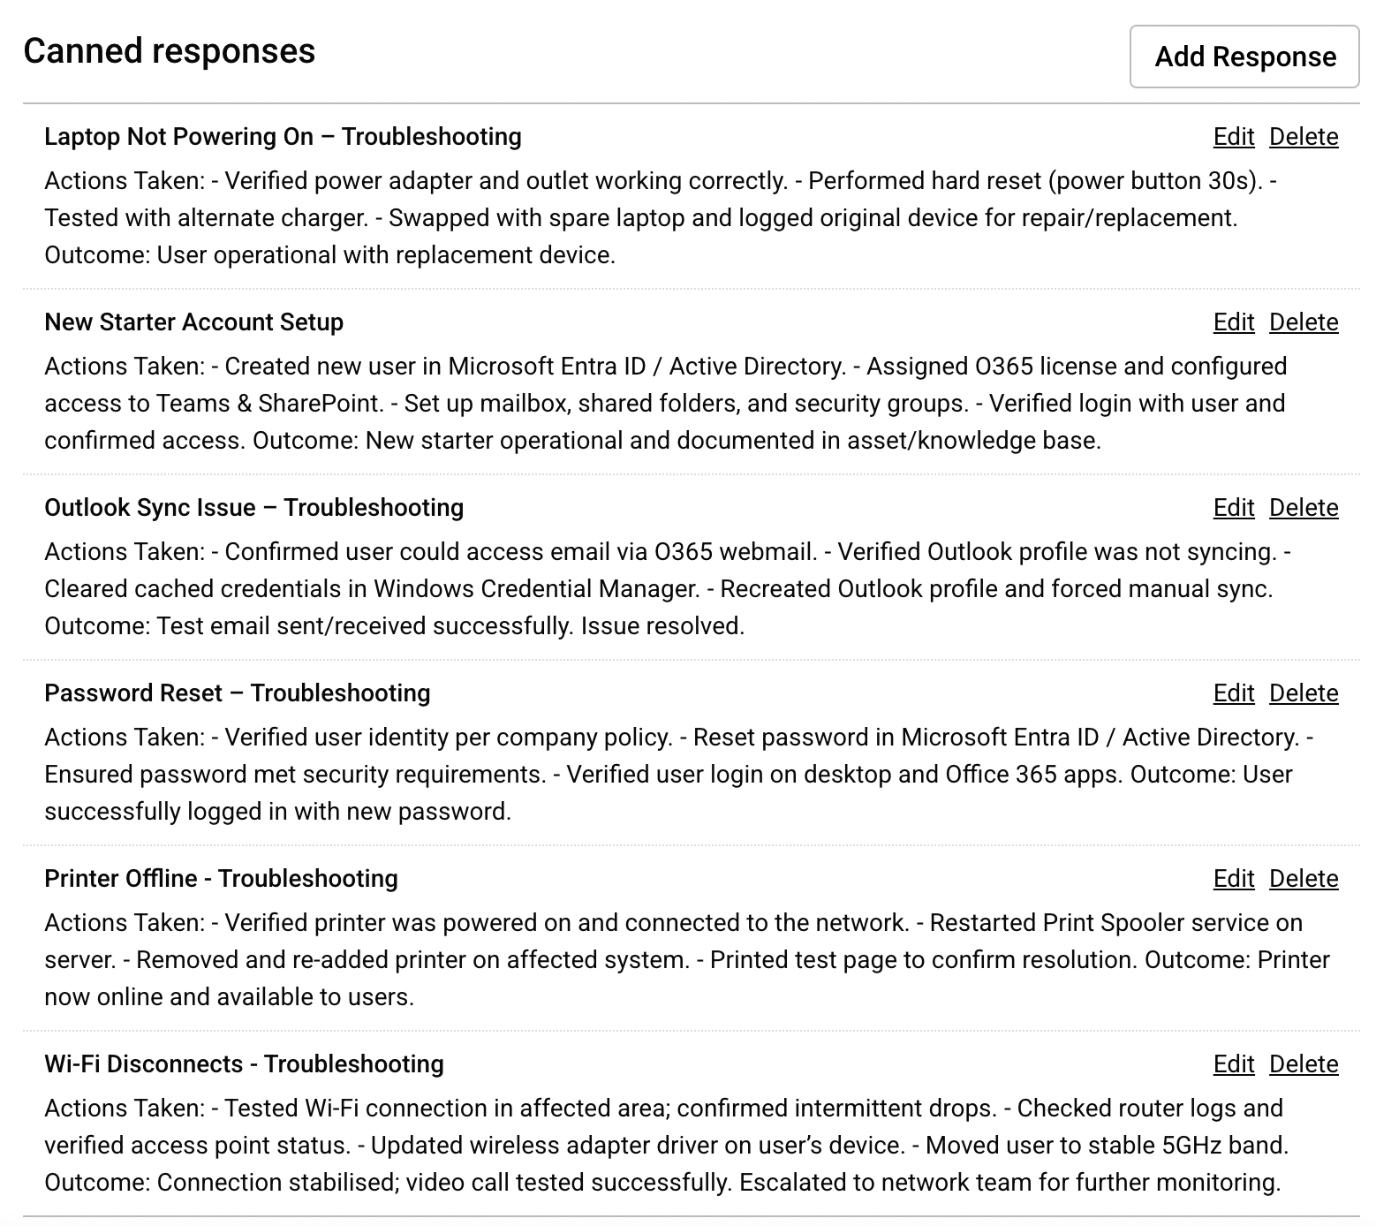

## ****Ticket #9 – Outlook Not Syncing with O365****

**Ticket Summary**

* User: Michael Lee
* Category: Software (auto-applied via Ticket Rule)
* Priority: Medium (auto-applied via Ticket Rule)
* Status: Closed

**Issue Description**  
User reported that Outlook desktop was not syncing with O365 emails. Messages appeared correctly in Outlook Web Access but not in the desktop client.

**Automation Used**  
The Spiceworks **Ticket Rule** automatically categorised this as Software and set priority to Medium based on keywords (“Outlook”, “Email”) detected in the ticket summary.

**Canned Response Applied**  
Outlook Sync Issue – Troubleshooting

**Actions Taken**

* Confirmed user could access mailbox via Outlook Web Access.
* Verified Outlook desktop profile was not syncing properly.
* Cleared cached credentials via Windows Credential Manager.
* Recreated Outlook profile and triggered manual sync.

**Resolution**  
Outlook re-synced successfully and both inbound/outbound mail flow was verified.

**Outcome**  
User confirmed full mailbox synchronisation. Ticket closed successfully.

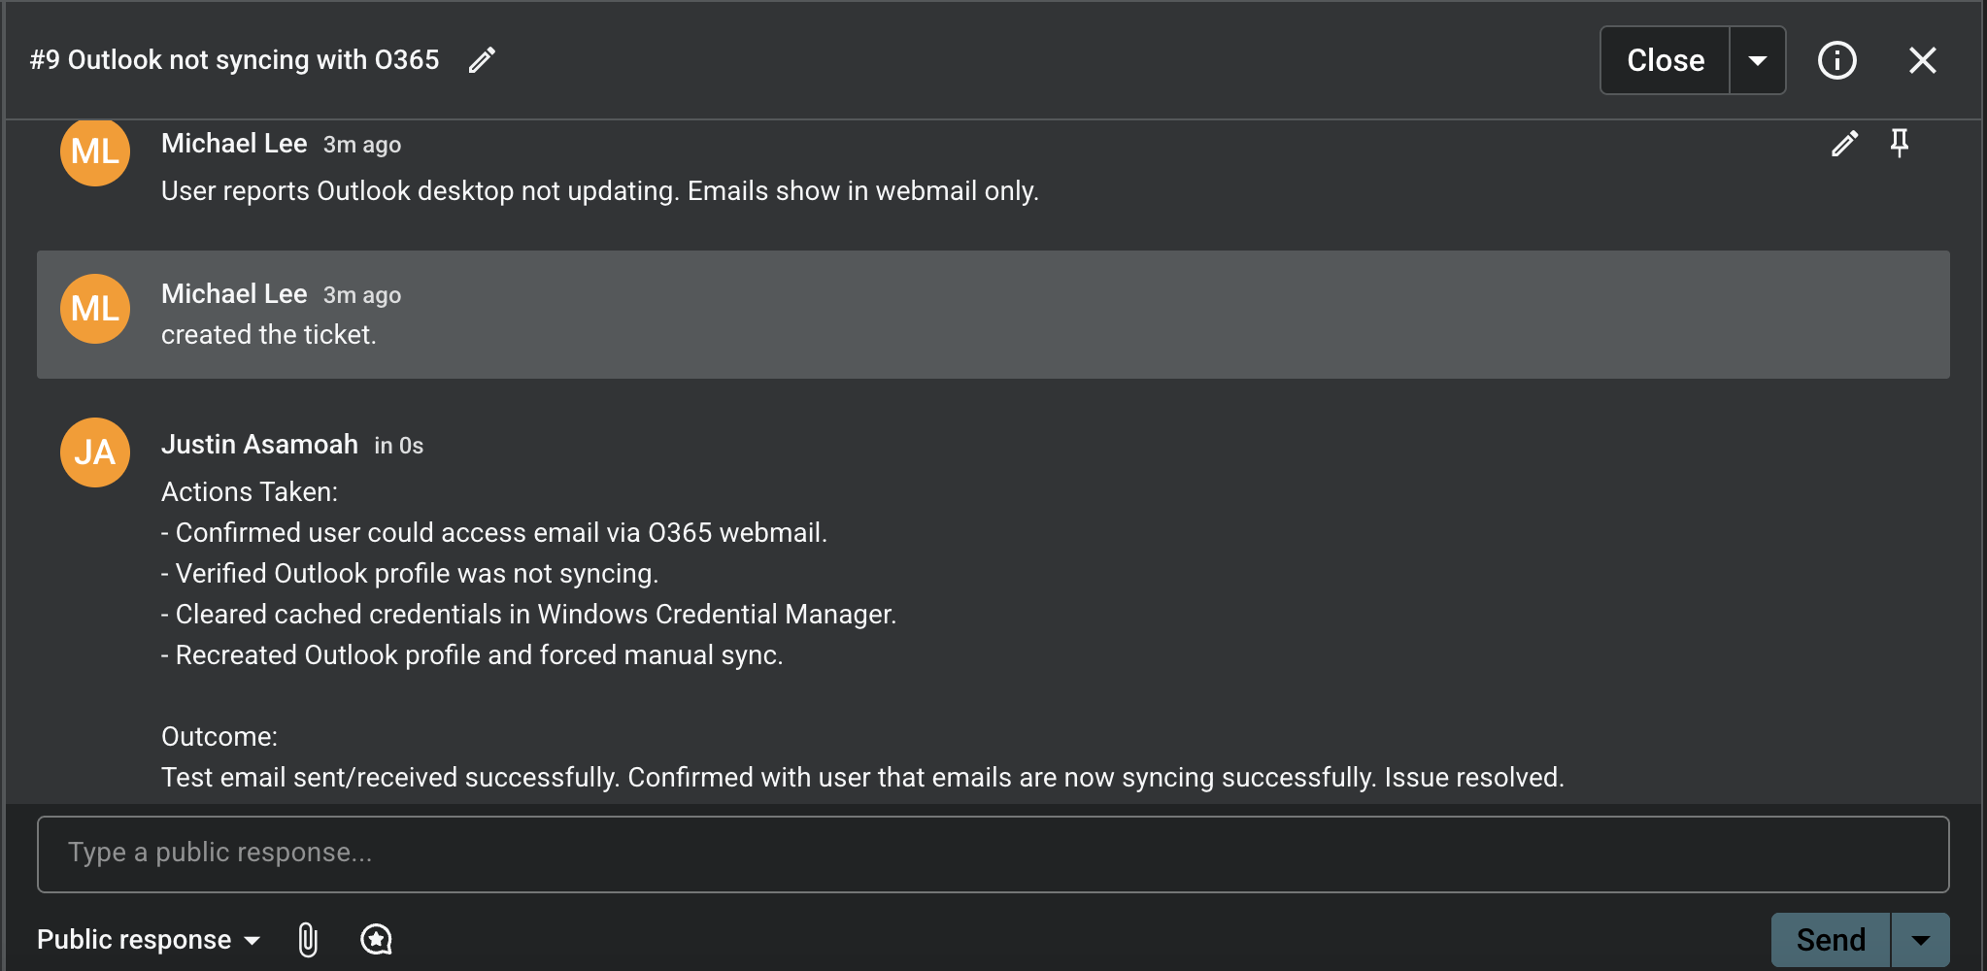

## ****Ticket #10 – User Locked Out of Account****

**Ticket Summary**

* User: Jane Doe
* Category: Accounts/Admin (auto-applied via Ticket Rule)
* Priority: High (auto-applied via Ticket Rule)
* Status: Closed

**Issue Description**  
User unable to access Teams and Outlook due to password expiry. Account locked pending reset.

**Automation Used**  
Spiceworks **Ticket Rule** detected keywords (“password”, “account”) and automatically categorised the ticket under Accounts/Admin with High Priority.

**Canned Response Applied**  
Password Reset – Troubleshooting

**Actions Taken**

* Verified user identity following IT security protocol.
* Reset password in Microsoft Entra ID / Active Directory.
* Ensured compliance with password complexity and expiry policy.
* Confirmed login success across desktop, Teams, and Outlook.

**Resolution**  
User credentials reset and verified successfully.

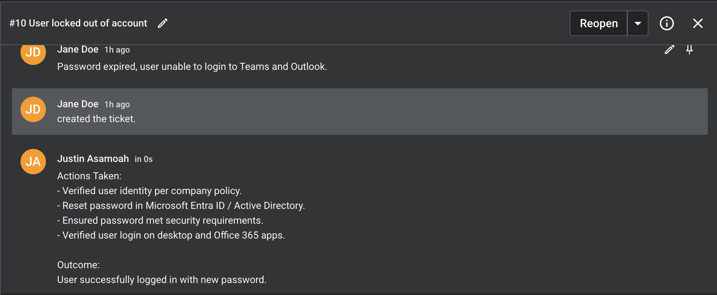**Outcome**  
Account restored. Ticket closed successfully.

## ****Ticket #11 – New Starter Account Setup Required****

**Ticket Summary**

* User: John Smith
* Category: Accounts/Admin (auto-applied via Ticket Rule)
* Priority: Medium (auto-applied via Ticket Rule)
* Status: Closed

**Issue Description**  
HR requested setup of a new employee account in Microsoft Entra ID with relevant O365 license and group access.

**Automation Used**  
Ticket automatically classified as Accounts/Admin using the “New Starter” rule.

**Canned Response Applied**  
New Starter Account Setup

**Actions Taken**

* Created new user in Microsoft Entra ID / Active Directory.
* Assigned Microsoft 365 license and configured Teams, SharePoint, and email access.
* Set up mailbox, security groups, and mapped network drives.
* Verified first login and MFA setup.

**Resolution**  
New account provisioned successfully and verified by the user.

**Outcome**  
User onboarded with all required access; process documented in the asset register and closed in Spiceworks.

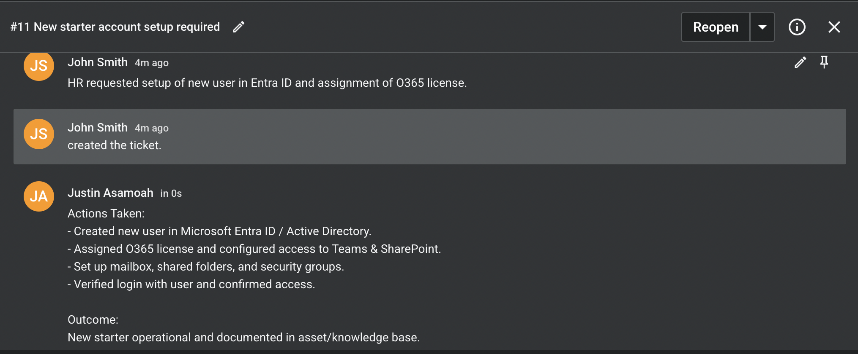

## ****Conclusion****

Through this portfolio, I have demonstrated my ability to:

* Diagnose, troubleshoot, and resolve a variety of technical issues.
* Communicate solutions clearly and effectively with end users.
* Document actions in a structured, professional format.
* Apply automation rules and canned responses to improve efficiency and consistency.
* Work across multiple IT areas, from user support to system administration and account management.

This collection of case studies highlights not only my **technical knowledge** but also the **soft skills** essential for IT support — problem-solving, adaptability, and a strong focus on user experience.

By showcasing both **manual troubleshooting** and **workflow automation**, this portfolio provides evidence of my readiness to succeed in an **IT Helpdesk or IT Administrator role** and to continue advancing into more complex IT and **cybersecurity-focused positions**.